Name of Experiment: Configuring FTP services in a server.
1. Introduction
File Transfer Protocol (FTP) is a standard network protocol used for transferring files between a client and server on a computer network. This lab demonstrates the process of configuring FTP services on a Cisco server using Packet Tracer.
2. Objectives
- Configure a basic network topology with a server and clients
- Set up FTP services on the server
- Create user accounts with appropriate permissions
- Test FTP connectivity and file transfer capabilities
- Verify security measures and access controls
3. Equipment Required
- Cisco Packet Tracer Software
- Server PT
- 2x PC clients
- 1x Switch
- Ethernet cables
4. Diagram
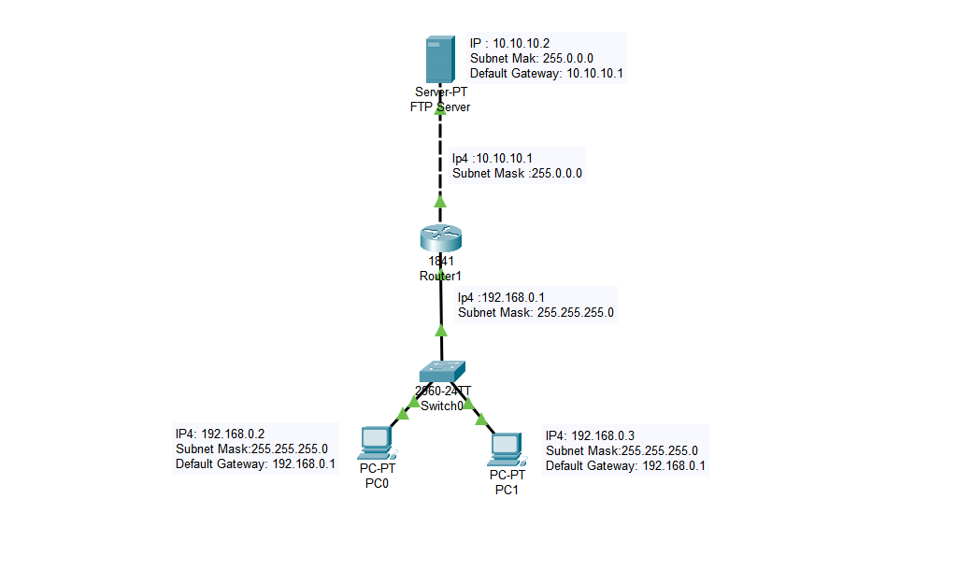
Figure : Configuring FTP services in a server

5. Procedure
I. Set Up the Network
- Drag and drop devices (e.g., PCs, servers, switch/router) into the workspace.
- Connect devices using copper straight-through cables.
II. Configure the Router
- Assign FastEthernet0/0 IP address and Subnet mask
- Assign FastEthernet0/1 IP address and Subnet mask
iii. Configure the FTP Server
- Click on the server.
- Go to the Services tab and enable the FTP service.
    - Assign IP address, Default Gateway and Subnet mask.
- Add user accounts with appropriate credentials.
    - Set Username and password in Services tab.
IV. Assign IP Addresses
- Open each device's configuration tab and assign static IPs based on your network design.
- Assign IP address, Default Gateway and Subnet mask.
V. Test Connectivity
- Use the Command Prompt on PCs to ping the server to ensure network connectivity.
VI. Create Files
- Create a text file using Text Editor option on one of the Device (PC0)
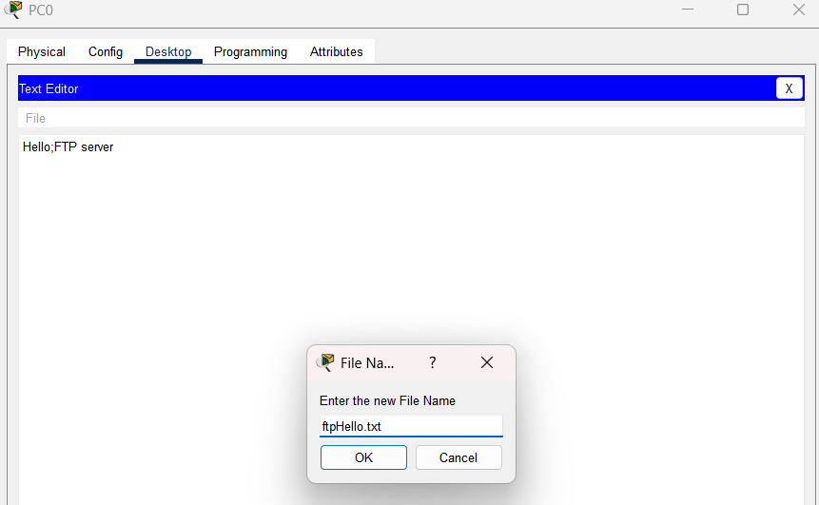

Figure : create a ftpHello.txt file
VII. Upload file on Server
- On a PC, use the Command Prompt and type: ftp [server IP address].
- Log in with the configured credentials.
- Use FTP commands put to upload files.
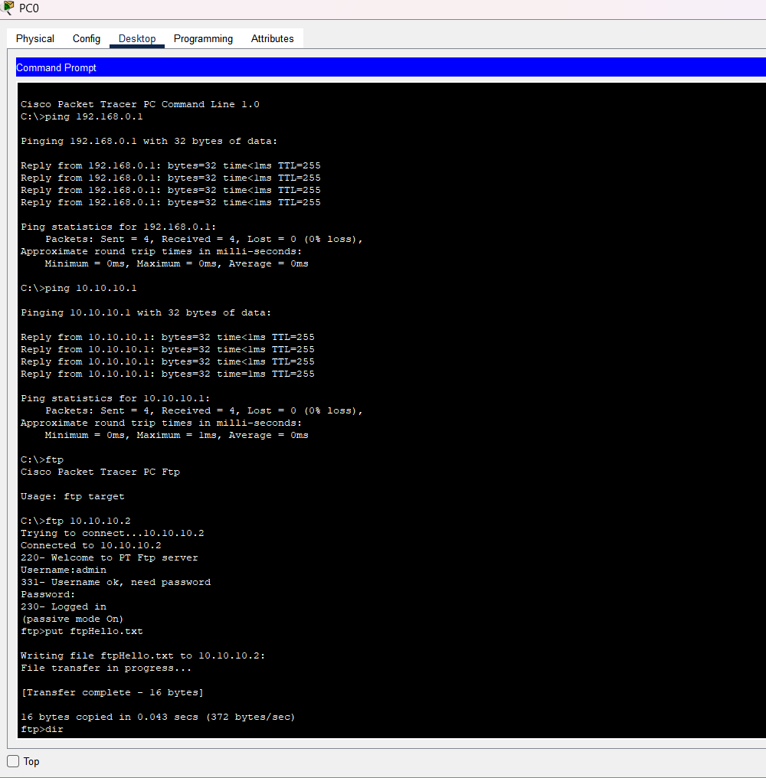
Figure : Upload file on Server

VIII. Access Files
- On a PC, use the Command Prompt and type: ftp [server IP address].
- Log in with the configured credentials.
- Use FTP commands get to download files.
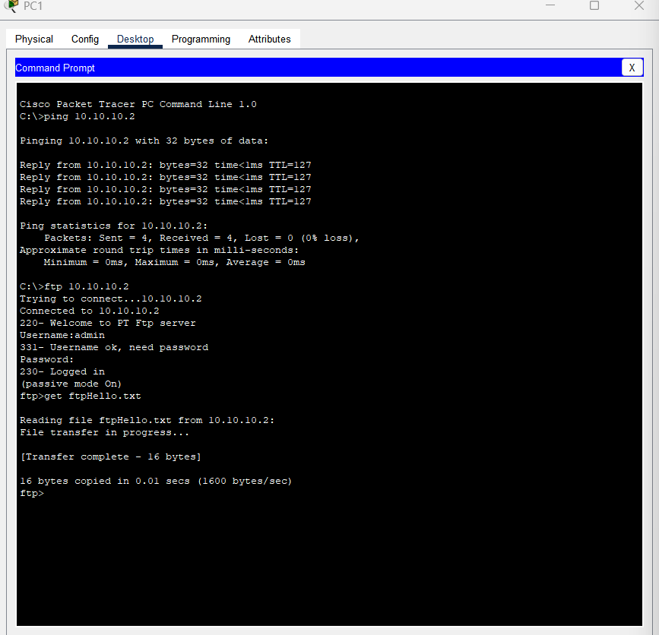
Figure :Access file on Server

6. Challenges Faced and Resolutions
Common issues and solutions:
- Connection timeout
- Verify IP configuration
- Check network connectivity
- Confirm FTP service is running
- Authentication failures
- Verify username and password
- Check permission settings
- Confirm user account status
7. Result Discussion
The configuration of FTP services on the server was successfully completed, and file transfers between the server and clients were verified. The network demonstrated how FTP allows users to upload and download files seamlessly, highlighting its role in managing and sharing data over a network.

8. Conclusion

This lab successfully demonstrated the configuration of FTP services on a Cisco server using Packet Tracer. The implementation provided secure file transfer capabilities while maintaining appropriate access controls.

9. References
- Cisco Packet Tracer Documentation
- RFC 959 - File Transfer Protocol (FTP)
- Cisco Networking Academy Materials

Name of Experiment: Configuring SMTP/E-Mail services in a server.
1. Introduction
SMTP stands for Simple Mail Transfer Protocol—it's an application used by mail servers to send, receive, and relay outgoing email between senders and receivers. It's also known as an outgoing mail server.
2. Objectives
- Set up a basic email server architecture.
- Configure SMTP services on the server.
- Create email user accounts and mailboxes.
- Test email delivery functionality.
- Implement basic security measures.
- Verify email routing and delivery.
3. Equipment Required
- Cisco Packet Tracer Software
- Server PT
- 2x PC clients
- 1x Switch
- Ethernet cables
4. Diagram
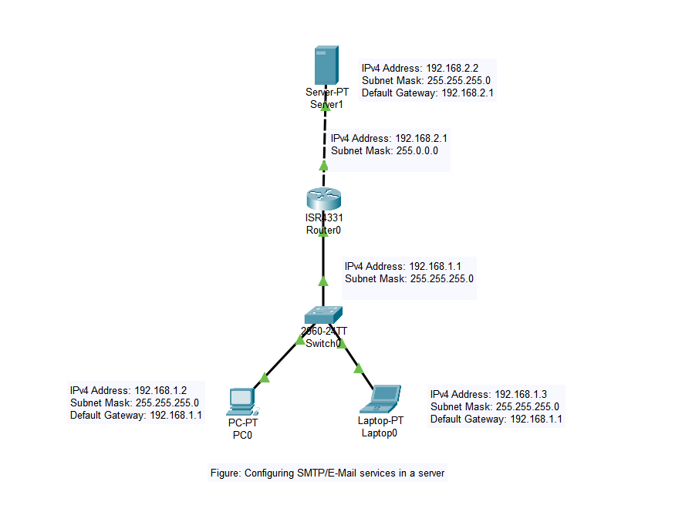
Figure : Configuring SMTP/E-Mail services

5. Procedure
I. Set Up the Network
- Drag and drop devices (e.g., PCs, servers, switch/router) into the workspace.
- Connect devices using copper straight-through cables.
II. Configure the Router
- Assign GigaBitEthernet0/0/0 IP address and Subnet mask
- Assign GigaBitEthernet0/0/1 IP address and Subnet mask
iii. Configure the Server
- Click on the server.
- Go to the Services tab and select Email.
- Enable the SMTP and POP3/IMAP services.
- Add user accounts with unique usernames and passwords.
IV. Assign IP Addresses
- Open each device's configuration tab and assign static IPs based on your network design.
- Assign IP address, Default Gateway and Subnet mask.
V. Configure the Client Email Settings
- On each PC, open the Email client application.
- Configure the email account.
  - Incoming mail server: [Server IP address] (POP3/IMAP).
  - Outgoing mail server: [Server IP address] (SMTP).
  - Enter username and password created on the server.
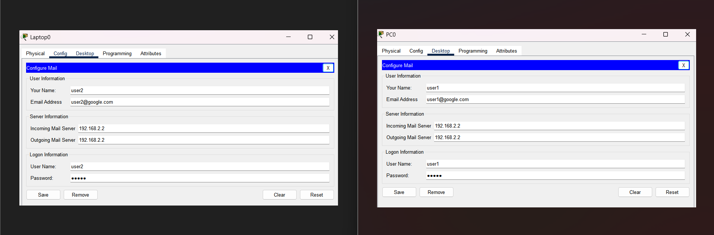
Figure :configure Email
V. Test Connectivity
- Use the Command Prompt on PCs to ping the server to ensure network connectivity.
VI. Test Email Communication
- Use one client to send an email to another client.

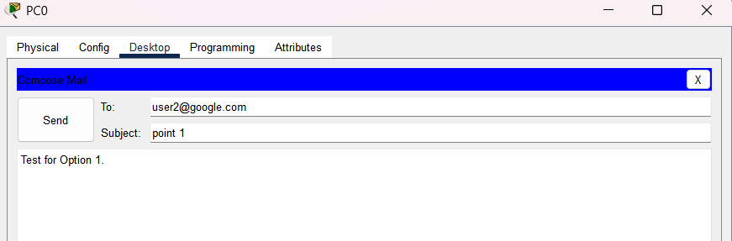
Figure: Compose Email
- Verify the email is received on the recipient’s client.
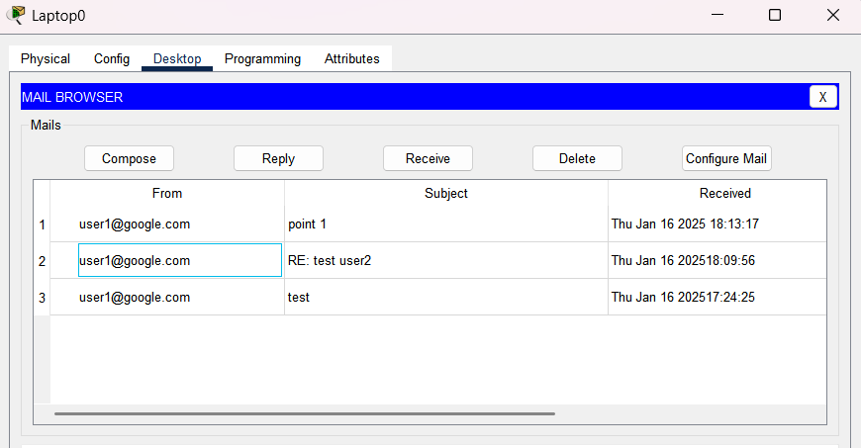
Figure :Verify received on the recipient's

6.Result Discussion
The configuration of SMTP and E-Mail services on the server was successfully completed. The network topology was functional, and the email communication between clients was validated through successful email transfers.

7. Challenges Faced and Resolutions
The configuration of SMTP and E-Mail services on the server was successfully completed. The network topology was functional, and the email communication between clients was validated through successful email transfers.
Challenges Faced and Resolutions
- Connection Problems:
- Verify network connectivity
- Check firewall settings
- Confirm DNS configuration
- Authentication Issues:
- Verify user credentials
- Confirm permissions settings
- Mail Delivery Delays:
- Check mail queue
- Monitor server resources

8. Conclusion

The successful configuration of SMTP services enables reliable email communication within the network environment. The implementation includes necessary security measures and demonstrates proper email routing functionality.

9. References
- Cisco Packet Tracer Documentation
- SMTP RFC 5321
- Cisco Networking Academy Materials

Name of Experiment: Configuring multiple servers with HTTP services (e.g. making their respective websites) and connecting them to their respective LANs, creating a WAN by connecting all the LANs and sharing their services with each other.
1. Introduction
This lab involves configuring HTTP servers on separate LANs, connecting them via a WAN, and enabling service sharing. It demonstrates practical networking concepts, including LAN/WAN setup, routing, and HTTP service management, simulating real-world distributed systems.
2. Objectives
- Configure HTTP services on multiple servers.
- Establish LANs for each server and connect clients.
- Create a WAN to link all LANs.
- Configure routing for inter-LAN communication.
- Implement web services on each server.
- Test connectivity and service sharing across networks.
3. Equipment Required
- Cisco Packet Tracer Software
- For Each LAN (×2):
- 1× Cisco Router (2911)
- 1× Layer 2 Switch (2960)
- 1× Web Server
- 3× Client PCs
- Ethernet cables
- For Wan Connections
- Serial cables for router interconnection
- WAN interface modules for routers

4. Diagram
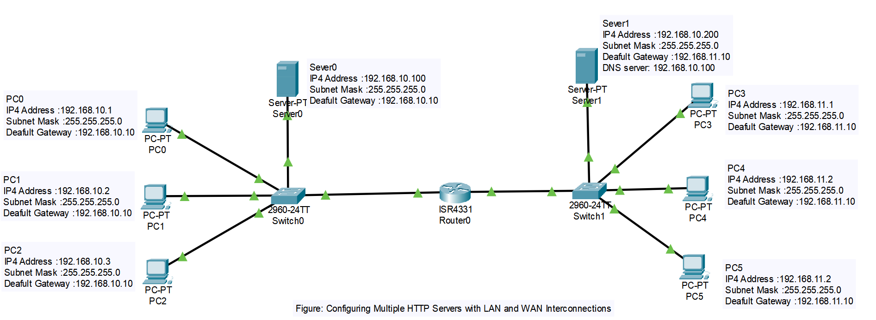
Figure: Configuring Multiple HTTP Servers with LAN and WAN Interconnections
5. Procedure
I. Set Up the Network
- Drag and drop devices (e.g., PCs, servers, switch/router) into the workspace.
- Connect devices using copper straight-through cables.
- Create separate LANs for each server with its clients
ii. Configure HTTP Services on Servers
On each Server
- Click on the server.
- Go to the Services tab and enable HTTP.
- Create a unique website for each server by modifying the Index.html file in the HTTP service.
IV. Assign IP Addresses
- Open each device's configuration tab and assign static IPs based on your network design.
- Assign IP address, Default Gateway and Subnet mask also DNS server address.
V. Connect LANs to WAN
- Use routers to connect the LANs.
- Configure serial interfaces on routers for WAN connections.

V. Test Connectivity
- Use the Command Prompt on PCs to ping the server to ensure network connectivity.
- Test WAN connectivity by pinging between devices in different LANs.
VI. Access HTTP Services
- From a client PC in one LAN, open a web browser and access the websites hosted on servers in other LANs using their respective IP addresses.
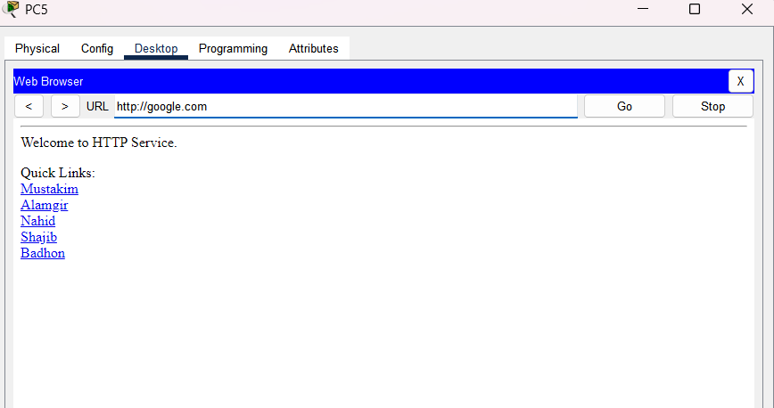
Figure: Access HTTP services

6.Result Discussion
- The configuration of HTTP servers on separate LANs and their interconnection through a WAN was successfully completed.
- Each server hosted a unique website, which was accessible from devices across the WAN.
7. Challenges Faced and Resolutions
- Routing Misconfigurations: Resolved by correctly setting up routing protocols like RIP or OSPF.
- Connectivity Issues: Fixed by verifying IP addresses and network connections.

8. Conclusion

This configuration demonstrates successful implementation of multiple HTTP servers across interconnected LANs, enabling organization-wide access to web services while maintaining network segregation and security.

9. References
- Cisco IOS Configuration Guide
- Apache HTTP Server Documentation
- OSPF RFC 2328
- Network Security Best Practices

